Chapter 13, Problem 81.

Use PSpice to find I₁, I₂, and I₃ in the circuit of Fig. 13.140.

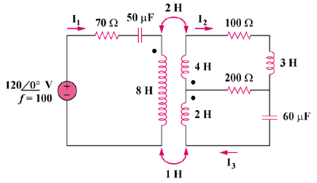

Figure 13.140
For Prob. 13.81.

